National Curriculum subject content

Year 9 Maths curriculum: Transformations, statistical diagrams and 3D shapes (see project plan and scheme of work)
Maths in Architecture Norham High School, North Tyneside

Project Summary

This exciting 7 week project was collaboratively planned and delivered by a maths teacher, an architect and a member of the NE Local Enterprise partnership. The aim was to introduce the students to a workplace setting where maths is used in a variety of ways and to connect their classroom learning to a real-world application. The project started with a visit to the architects’ office where the students were presented with a project brief (Ouseburn Farm Goat House Challenge) and a series of tasks. All of these required to students to apply their mathematical knowledge (three dimensional shapes, statistical diagrams and transformations.) The students continued to work on their designs in their lessons supported by their class teacher, and by regular visits from the architect and two university maths undergraduate students. The project culminated in a presentation of the students work.

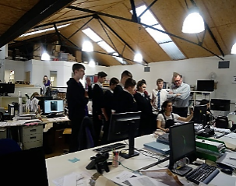
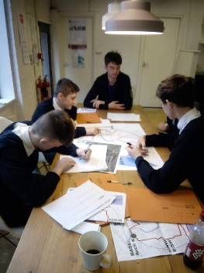
Skill development

- Applying maths subject content knowledge to unfamiliar real-life problems
- Working to deadlines
- Working independently and in a group
- Creating a final product (presentation, 3D model)
- Communicating ideas, findings and the maths used, to an external audience (in lessons to the architect/ university students and during the final presentation to an external audience)
Cultural capital

The project launch event involved a whole day visit to the architect’s office in the Ouseburn, Newcastle. The students were introduced to the staff and their roles. They worked on their project in the office spaces enabling them to experience a work environment.
The architect continued to visit the students every week supporting them in their maths lessons.
Two undergraduate university students studying Maths and Statistics at Newcastle University joined the school students on the initial visit and then worked with them in a Maths lesson back in school. This introduced the school students to the potential of studying Maths at university.
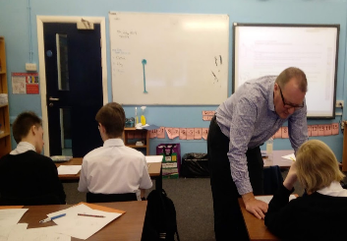
Gatsby Benchmarks

BM4. Linking curriculum learning to careers​ BM 5: Encounters with employers and employees​ BM 6: Experience of workplaces​ BM7: Encounters with further and higher education​

Week 1 | Week 2 | Week 3 | Week 4 | Week 5 | Week 6 | Week 7
Architect visits students in school to introduce himself and set the design challenge | Students spend the day at the architect’s office, tour the locality in order to understand the context of the challenge and start to work on the design tasks.  Supported by University undergraduate students | Students work on the challenge in their maths lessons  Supported by University undergraduate students | Students work on the challenge in their maths lessons  Supported by the architect | Students work on the challenge in their maths lessons  Supported by the architect | Students work on the challenge in their maths lessons and prepare their presentation | Students present their solutions to the architect.  External audience: architect, university researcher, NE LEP
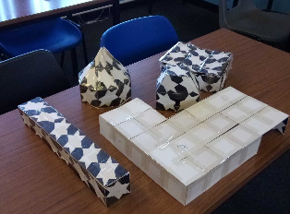
Launch event/ Final product and showcase

The project launched with a visit to the architect’s office, where the students were able to meet the staff and work alongside them on their own tasks. This introduced them to a workplace environment but also highlighted the seriousness of the challenge. The students were treated like architects with appropriate terminology was used throughout.
The aim of the project was to design a goat shed for a city farm based in the locality of the architect’s office. The challenge had specific mathematical content, but also involved the creation of a 3D model and presentation. Criteria were set both for the design of the goat shed and for the detail expected in the presentation.
The showcase event involved lunch with the external partners followed by the students presenting their work

We worked together and we were listened to.
The most broad message and perspective that there will be work as difficult as this in the future and that this project was preparing us for this.

I learnt how maths is relevant outside of school.
Project activity and timescale

Project feedback

Useful links/resources/ideas

Newcastle University Outreach: https://www.ncl.ac.uk/schools/team/
School of Maths and Stats outreach, Newcastle University: https://www.ncl.ac.uk/maths-physics/outreach/teachers/
If your school isn’t near Newcastle, find your local university/college outreach teams.
Resources relating to this specific project on our website: the project timetable with activities, the Goat Shed challenge, the maths scheme of work
General resources on our website: blank planning tools, links to useful websites, more case studies

Learning for next time

- The collaborative planning of the project needs to take place in a timely manner and must not be rushed.
- The point in the academic year when the project takes place needs to be considered carefully so that there are enough lessons to produce a high quality product and presentation.
- The university students should come in more often to work alongside the school students. Approaching the education outreach team in the School of Maths in a timely fashion could facilitate this.
- Regular communication between the students and the architect is important in order to keep the momentum going and to address queries. Although ideally this is in person, if ways could be developed that overcame GDPR issues so that perhaps messages could be sent and answered, this has the potential to allow more flexible opportunities for communication.
- The partner setting the challenge needs to engage with the project in person at 4 key moments:
- To set the project off
- To accelerate the project – deal with issues and create a sense of urgency regarding the deadline.
- Introduce a scenario to move the project forward, possibly in a different direction. X has happened so you need to make changes accordingly.
- To attend the final showcase event.
- There is real potential for this to be a cross-curricular project. The scaled models could be made in D&T. There is potential for this to be part of the geography lessons through the exploration and focus on the local area.
Involving other curriculum areas in the project would enable the students to begin to see the links between subjects.
- The project could include visits to the universities in the city. There are opportunities available to experience the campuses and different departments-maths, architecture and geography.

